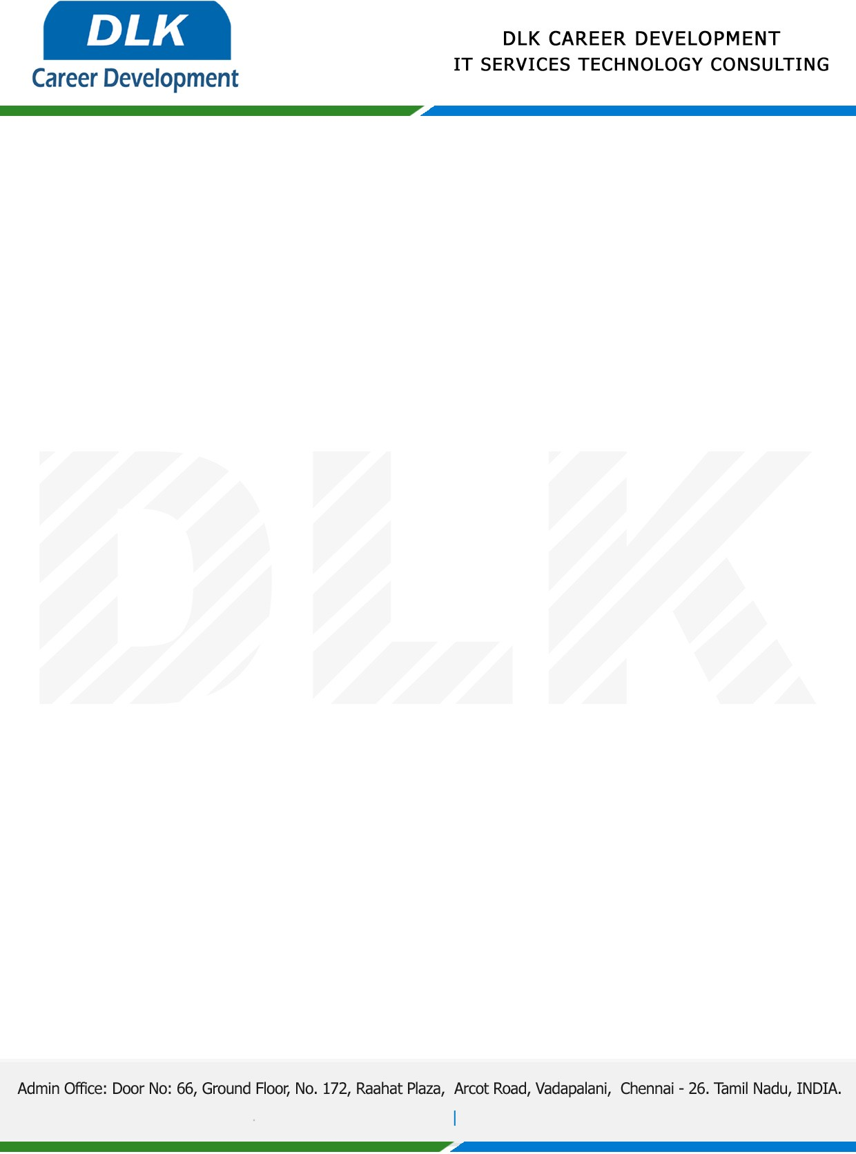

**Date: 06 February 2023**

**COURSE COMPLETION CERTIFICATE**

**Name:** MS FIONA V

**Reference Number:** 966852207895

**College Name:** [St. Joseph's College of Engineering, (BE-CSE).](https://stjosephs.ac.in/)

**Batch ID:** 2022 – 2026

**Program language:** Python Technology

*{Basic of Python,* OOPs*, Loops,Conditions, Modules}*

**Duration:** December 2022and January 2023 **(2 Months)**

**MS FIONA V,** displayed professional traits during the Course period and managed to complete all assigned tasks as required. She was Hardworking, dedicated and committed it was a pleasure with us in this short period.

**We** **Wish all the best for your future.**

For **DLK CAREER DEVELOPMENT**

**HR Manager**

**VELMURUGAN J**